TF-IDF (Term Frequency – Inverse Document Frequency)

Definition
# Source: AI Source: Provided by: [Data Path: Persons Table -> ID Column: 1, Name_En Column: Motasem Essam] -> From: [ChatGPT] on [12/10/2025]
TF-IDF is a text encoding technique that transforms text into numerical features by weighing words based on their importance in a document relative to the entire dataset. It balances word frequency in a document with how common or rare the word is across all documents.

Key Idea
# Source: AI Source: Provided by: [Data Path: Persons Table -> ID Column: 1, Name_En Column: Motasem Essam] -> From: [ChatGPT] on [12/10/2025]
- Term Frequency (TF) measures how often a word appears in a document.
- Inverse Document Frequency (IDF) reduces the weight of words that appear in many documents, highlighting more informative words.
- TF-IDF combines these to give higher scores to words that are frequent in a document but rare overall.

Formulas
# Source: AI Source: Provided by: [Data Path: Persons Table -> ID Column: 1, Name_En Column: Motasem Essam] -> From: [ChatGPT] on [12/10/2025]
Term Frequency (TF):
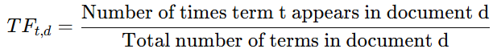
[
TF_{t,d} = \frac{\text{Number of times term t appears in document d}}{\text{Total number of terms in document d}}
]
Inverse Document Frequency (IDF):
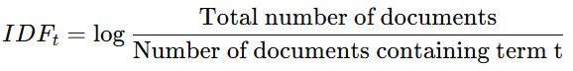
[
IDF_{t} = \log \frac{\text{Total number of documents}}{\text{Number of documents containing term t}}
]
TF-IDF:
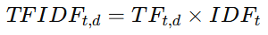
[
TFIDF_{t,d} = TF_{t,d} \times IDF_t
]

Example
# Source: AI Source: Provided by: [Data Path: Persons Table -> ID Column: 1, Name_En Column: Motasem Essam] -> From: [ChatGPT] on [12/10/2025]
Original documents:
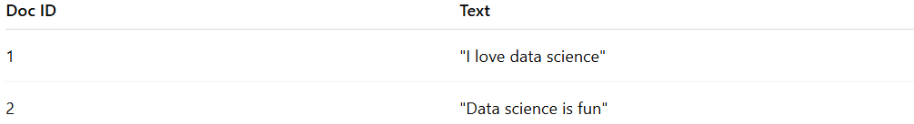
Doc ID | Text
1 | "I love data science"
2 | "Data science is fun"
Step 1 – Calculate TF:
- Doc 1: "data" appears 1/4 = 0.25
- Doc 2: "data" appears 1/4 = 0.25
Step 2 – Calculate IDF:
- "data" appears in both documents → IDF = log(2/2) = 0 (common word)
- "love" appears in 1 document → IDF = log(2/1) ≈ 0.693
Step 3 – Compute TF-IDF:
- "love" in Doc 1: 0.25 × 0.693 ≈ 0.173
- "data" in Doc 1: 0.25 × 0 = 0

Applications
# Source: AI Source: Provided by: [Data Path: Persons Table -> ID Column: 1, Name_En Column: Motasem Essam] -> From: [ChatGPT] on [12/10/2025]
- Text classification (spam detection, sentiment analysis)
- Information retrieval (search engines)
- Document clustering and ranking

Advantages
# Source: AI Source: Provided by: [Data Path: Persons Table -> ID Column: 1, Name_En Column: Motasem Essam] -> From: [ChatGPT] on [12/10/2025]
- Highlights important words while downweighting common ones
- Reduces noise from frequently occurring words
- Produces numerical features for machine learning models

Disadvantages
# Source: AI Source: Provided by: [Data Path: Persons Table -> ID Column: 1, Name_En Column: Motasem Essam] -> From: [ChatGPT] on [12/10/2025]
- Still ignores word order
- Can produce high-dimensional sparse matrices
- Requires preprocessing and cleaning for optimal performance

